**Task 1 for submission**

*Part A addresses* ***Unit Objective 1 – Comprehend accounting concepts, principles and processes relating to accounting and end-of-month reporting for a service business.*** *The cognitive verbs* ***describe and explain*** *are components of* ***comprehend*** *ie to show your comprehension of a concept, principle or process, you must describe and explain the concept, principle or process.*

**Part A**

1. In 50 – 75 word paragraphs, **describe:**

1. accounting period concept

For accounting purposes, the accounting period concept assumes that the life of a business is divided into arbitrary time periods. These accounting periods are usually a month, a quarter, six months or a year. For every accounting period, the aim is to calculate a profit figure that is as accurate as possible.

1. Statement of Profit or Loss

A Statement of Profit or Loss is prepared outside the ledger for presentation to interested parties, detailing the various revenues and expenses for a period and calculating the resultant profit or loss. The Statement of Profit or Loss may be prepared monthly, quarterly or at the end of a financial period.

2. In 50 – 75 word paragraphs, **explain** the relationship between:

1. profit and the accounting equation

Revenues and expenses have an indirect relationship with the accounting equation, whereby revenues increase owner’s equity and expenses decrease owner’s equity. A net profit (R-E) will increase owner’s equity and a net loss (R-E) will decrease owner’s equity.

1. income and revenue

The definition of income is complex, and includes both revenue and gains. Income includes unrealised gains on revaluation of securities, gains on the revaluation of property, exchange differences as a result of foreign operations, as well as revenue received from the normal operation of business. Revenue is recognised when it has been earned. For a service business, this means when the service has been performed.

1. In 50 – 75 word paragraphs **explain** the interrelationship between:
2. expenses, revenue and profit

In order to calculate profit, we subtract our expenses from revenues. Revenues are recognised when they have been earned. For a service business, this is when the service has been performed. The expenses incurred in order to earn that revenue must be recognised within the same accounting period to determine an accurate profit or loss.

1. the profit or loss determined in the Statement of Profit or Loss and the owner’s equity section of the Statement of Financial Position.

Once a profit or loss has been determined for the accounting period, the profit or loss figure is transferred to the owner’s equity section of the Statement of Financial Position. A profit figure will increase the owner’s equity, as revenues are higher than expenses, whereas a loss figure will decrease the owner’s equity as revenues have been less than expenses.

*Part B addresses* ***Unit Objective 2 - Apply accounting principles and processes relating to accounting and end-of-month reporting for a service business.***

**Part B**

Refer to text book page 109 ex 4.5.

You are required to **apply** accounting principles and processes for a service business to:

* prepare a Statement of Profit or Loss for Majestic Agents and Services for the year ended 30 June 2019.

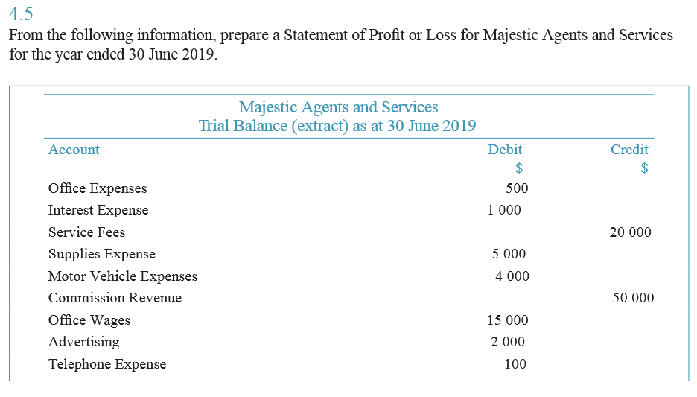

*Excel